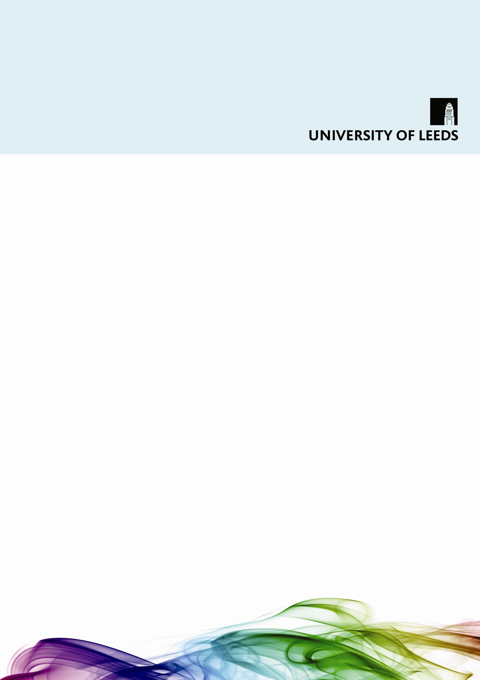

How to make your School or
Service’s written and printed
information accessible

Equality Service

For more information, or for a copy of this guide in an alternative format, please contact the University’s Equality Service.

Equality Service
University of Leeds
LS2 9JT

Email: equality@leeds.ac.uk
Telephone: 0113 343 3927
(Calls via the RNID Typetalk service are welcome)
Fax: 0113 343 3944
Web: www.equality.leeds.ac.uk

Contents

SECTION 1: Why is accessibility important? 4
SECTION 2: The format and layout of your document 6
SECTION 3: Providing contact details and asking about people’s
access requirements 10
SECTION 4: Adding an ‘accessibility statement’ to all your publications 13
SECTION 5: Telling students about the University’s Disability Team 16
SECTION 6: Telling students about equality and diversity issues 18
Appendix: A final checklist 19

SECTION 1: Why is accessibility important?

Schools, Faculties and Services across the University produce a wide range of written and printed materials, including departmental or programme handbooks, posters, leaflets, event invitations, lecture handouts and reading lists.

If a document is not well-designed, or if it is overly complex or full of jargon, then we can all find this off-putting and difficult to understand. However, there are some groups of people who may find it particularly difficult to access various kinds of written or printed information. For example:

- People who are partially-sighted may have difficulty accessing information that is poorly-designed or produced in a small typeface. People may also find it difficult to access electronic files which are incompatible with assistive software (such as ZoomText – a piece of software that enables users to enlarge the information presented on a computer screen).
- People who are blind will often require information in an alternative format (e.g. braille, audio or electronic formats) or in an electronic format which is compatible with assistive hardware or software (e.g. a screen reader package, such as Jaws, which reads out the information presented on a computer screen).
- People with specific learning difficulties (e.g. dyslexia) or autism spectrum conditions (e.g. Asperger Syndrome) may find complex written documents difficult to access.
- People whose first language is not English may find written documents difficult to understand. This may include, for example, some international students, people who are reading your document in other countries or deaf people whose first language is British Sign Language.

This booklet contains some simple guidance on how to make your written and printed materials accessible. Following this guidance is important because:

- It's fair – people should receive information that is accessible to them. Access to information enables all of us to make decisions and lead independent lives.
- It's the law – the Disability Discrimination Act means there is now a legal duty to meet the information needs of disabled people.
- It makes sense – if you are spending your time producing written or printed materials, you want people to be able to read them! Particularly when you are producing materials aimed at large numbers of current or prospective students or staff members, you should assume that a proportion of your target audience will find it difficult to access the information if you are not following some basic guidelines.

We would encourage Schools, Faculties and Services to use this booklet by:

- Initiating a discussion amongst your team – perhaps at a staff meeting – to ensure that all staff members are aware of these issues and what to do to make your information accessible. You could use the opportunity to gather together a selection of documents that your team has produced in the past, and think afresh about their design and content in order to inform your future work.

- Perhaps coming up with some agreed local standards in relation to any materials you are producing.

- Ensuring that those staff members in your team who have a lead responsibility for producing high-profile written or printed materials are aware of, and work to, these guidelines. This might include, for example, your marketing officers, members of staff who lead on the production of lecture handouts, authors of departmental/programme handbooks, etc.

- Giving a copy of this document to any designers (internal or external) you are working with on a particular design project, to ensure that they are aware that these issues need to be taken on board from the outset. At a University level, we will we will be doing some work to inform the main design companies we use about our expectations in this area, but it never hurts for you to raise these issues again when initiating a particular project.

If you would like a more detailed guide to producing accessible written information – including issues such as web design and designing signage – we would recommend purchasing the RNIB’s publication, See It Right. This can be ordered online at www.rnib.org.uk/seeitright or from the RNIB customer services helpline – telephone 0845 702 3153).

SECTION 2: The format and layout of your document

- Use a simple and uncluttered layout for all documents.

- Use only clear “sans serif” fonts. “Sans serif” means that the font does not have the tiny lines at the end of each character.

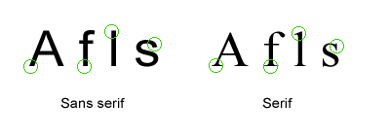

Arial is a particularly good choice of sans-serif font in relation to accessibility, and is the University’s corporate font. Avoid using serif fonts, such as Times New Roman or Courier.

- In relation to font size, it is best to avoid using a font smaller than 12pt at all times. If you are producing something which needs to be read from some distance away (e.g. a poster), then you should use a much larger font. It is also worth noting that when text is reversed (e.g. white text is used on a black background), the text may need to be made bold or larger in order to ensure that it is clear and easy to read.

If someone requests correspondence or a document in “large print” format, the font size used should be a minimum of 16pt, although it is very important to ask the person concerned what size they would like the text in these circumstances.

- Use plain English and avoid the use of jargon and unexplained abbreviations wherever possible. Visit www.plainenglish.co.uk for further information about how to use plain English. Providing a glossary within a document is often a useful way of making a document more accessible when using jargon is unavoidable.

- Avoid using block capitals wherever possible (particularly for whole sentences). Lower case letters provide the reader with more visual clues as to the letters used in each word, and they, therefore, make the text easier to read.

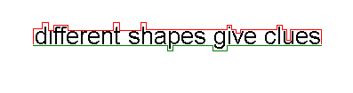

- Use italics sparingly. For example, whilst italics may be used to highlight words or short phrases, try to avoid using them to highlight whole sentences or blocks of text, as they make text more difficult to read.

Be careful when using italics. Use them sparingly because… | …italicising the text will make most fonts more difficult to read.

- Switch off “hyphenation” setting in word processing software so that long-
-er words are not split over two lines of text.

- Align text to the left margin whenever possible. In left-aligned text, it is easy to find the start and finish of each line and left-aligned text also provides even spaces between the words. Justified paragraphs often produce stretched or crammed lines of text which can be difficult for partially sighted people to read. Aligning text to the right margin can also be particularly problematic for people with visual impairments. Centred text should not be used for blocks of text; however, it may sometimes be used for large titles or main headings. Take a look at the following examples:

The RNIB recommends aligning text to the left margin, as in this paragraph. In left-aligned text, it is easy to find the start and finish of each line and even spaces exist between the words. Also, if someone is ‘zooming in’ on an electronic version of your document on their computer screen and scrolling down the page, they may miss be more likely to miss headings, etc. which are right-aligned or centred.

Justified text can be readable if the space between the words is consistent. However, this is difficult to achieve with standard word processing or desktop publishing software. It is therefore best avoided as it can result in stretched or crammed lines of text. Sometimes, partially-sighted people can mistake large gaps between words for the end of a line.

Aligning text to the right margin, which produces a ragged left margin, is problematic for people with visual
impairments. Each new line starts in a different place and is therefore more difficult to find.

Centred text, where each line starts and ends in a
different place, is even more difficult to follow and should not be used for blocks of text. Centred text can
sometimes be used for very large headings, although
left-aligned headings are generally much more accessible.

- Consider carefully how you might use images, photos and illustrations in publications. In many cases, using images can help people to understand and retain information. They can also be useful for making the design of your poster/publication/sign, etc. more appealing. However, people who are accessing your document electronically may not be able to access the images. Therefore try to avoid conveying meaning in images which is not also repeated in your text. Also, when using illustrations, you must ensure that you avoid using designs that involve printing wording over an image (e.g. a photograph or a graphic) as this will generally make the text harder to read.

- Always use high contrast colour schemes (e.g. white text on black background, or dark blue text on cream background). Using different shades of the same colour for text and background can make the text difficult to read. Also, some background colours (e.g. bright yellow or bright red) can make text in any colour difficult to read.

Poor contrast | High contrast

When placing reversed text on a dark background, you may need to increase the weight of the type you use. This is because white text on a dark background appears smaller. | Making the text bold makes it easier to read.  Changing to another font and increasing the font size will enable even more people to read your text.

Difficult to read | Easier to read

Difficult to read | Easier to read

White text on a black/dark background can be more difficult to read than… | …black/dark text on a white background. By using a white background, you reduce the amount of glare from the page.

- Avoid using glossy paper, or paper with patterned surfaces or mottled flecks whenever possible, as these can make text more difficult to read.

- If you are providing a form for people to fill in, you should also think carefully about the amount of space that people will need to complete the required information. Always try to provide more space than most people will require. This is because people with particular conditions, such as arthritis and certain types of visual impairment, can find forms much easier to complete as a result. As a guideline, when providing lines for people to write on, ensure that these are at least 1cm apart.

SECTION 3: Providing contact details and asking about people’s access requirements

- When providing someone with your own, or someone else’s, contact details, provide as many methods of contacting you/your team as possible, including telephone number, fax number, email address and postal address.

- When you provide your office’s telephone number, ideally you should also make it clear to people that you welcome RNID Typetalk calls (i.e., telephone calls from people who are deaf). This is particularly important when a phone number is the only or main way in which you want people to contact your office.

For example, simply explain that you welcome RNID Typetalk calls after providing the relevant telephone number as follows:

For more information about this event, please telephone Sam Jones on 0113 123 4567. We also welcome calls to this number from deaf people using the RNID Typetalk service.

- When writing to someone or emailing someone about an event or meeting (even a one-to-one meeting), we should always ask the recipient whether those attending will have any specific requirements. Here are examples of how to ask this question:

If you are writing a letter, you can include a statement as follows:

We are committed to meeting the access requirements of those attending this meeting. If you have any specific access requirements, please contact <insert name> by telephone: <insert phone number> (calls via RNID Typetalk are also welcome), fax: <insert fax number> or email: <insert email address>

Or, if you are producing a form for people to complete, include a question along the following lines:

We are committed to meeting the access requirements of those taking part in this event. Please tell us about any specific requirements you have in relation to this event.

________________________________________________________________________________________________________________________________________________________________________________________________

Should you wish to discuss your requirements further, please contact <insert name> by telephone: <insert phone number>, fax: <insert fax number> or email: <insert email address>

Remember that you should also ask if anyone has any specific requirements if you are arranging a meeting by email or telephone. For example, you can simply ask:

“Could I just ask whether anyone attending from your organisation has any specific requirements, perhaps in relation to accessing our premises or any other aspect of the meeting?”

Occasionally, you may need to provide a deadline for people to get back to you about their requirements in order to provide you with enough time to make the necessary arrangements (e.g. for booking interpreters, etc). If this is necessary, you must always ensure that the deadline given is a reasonable one and that it also takes account of any timescales from our side, (e.g. to arrange and book a BSL interpreter, etc. which can require several weeks’ advance notice).

Also, if someone informs you of their requirements after our deadline, you must still do everything you can to meet their needs. Providing a deadline is only a mechanism for trying to ensure that requests come in promptly. You could say something like: “If possible, please let us know about any such requirements by <insert date>”.

- At meetings or events where food is provided, ask a separate question about dietary requirements in addition to asking about any other requirements that people might have. It is worth noting that it is normally good practice to ensure that at least half of the food options provided are vegetarian, irrespective of the responses to this question.

- When providing written information about an event/meeting, publicise the facilities that will be made available to promote wider access. It is much better to be honest about any barriers which exist, rather than waiting until people turn up at the event and find they cannot access it.

For example, if you were arranging an event, you might say this in the publicity materials/invitations:

The venue for this event is on the ground floor and can be accessed from the main entrance without needing to use stairs or a lift.

An induction loop/infra-red system will be in use for hearing-aid users or those who are hard of hearing. To borrow a headset to use the infra-red system, please contact….

Both vegetarian and meat options will be provided. Please let us know if you have any other dietary requirements by contacting...

If barriers to full access do exist (e.g. the venue is not fully accessible for wheelchair users), explain clearly what these barriers are (e.g. “There are four steps leading up from the pavement outside the building to the front door.”) It is better to be honest about these barriers than put someone in the position of encountering them when they arrive.

For example, you might say:

The venue that is booked for this event is on the first floor and is only accessible via a short flight of stairs, which has a handrail. If this makes it difficult for you to access the event, please contact us and we will do our best to find a more accessible alternative venue.

Of course, choosing a more accessible venue in the first place is clearly a
better idea!

SECTION 4: Adding an ‘accessibility statement’ to all your publications

On all publications, you should incorporate a simple accessibility statement which tells anyone who requires a copy of the document in an alternative format how to go about requesting this.

Here is a sample accessibility statement which you can use or adapt:

A copy of this document is also available electronically at <insert web link>

For information in alternative formats (for example, in braille, large print or an electronic format), please email <insert email address>. You can also contact us by fax (<insert fax number>) or by telephone (<insert phone number>).

This accessibility statement should be written in a clear font (at least font size 12 – or ideally font size 14+) on the inside or outside cover of the document (either back or front cover). Displaying the statement in this way means that, even if someone cannot access the rest of your document, they might be able to access this statement. Ask yourself the question:

If I was blind or partially-sighted
and needed this publication in an alternative format in order to access it, what statement would make me feel that this was an organisation that wanted to help me?

How do you get a document converted into an alternative format?

The University of Leeds has a transcription centre on campus (the RNIB & University of Leeds Transcription Centre), which is based within the University’s Equality Service.

The Transcription Centre converts printed information (e.g. textbooks, etc.) into accessible formats – including braille, large print, digital audio, tactile diagrams and e-text – particularly for people who are blind or partially-sighted.

In the case of materials produced by a School/Faculty (e.g. lecture handouts, slides, departmental handbooks), the relevant School/Faculty is normally charged for this work. For other materials (e.g. textbooks), most students will have access to funding (e.g. Disabled Students Allowances) to pay towards the costs.

Schools/Faculties should not normally turn down a request for information in an alternative format on the basis of cost alone, even if there is no local budget to pay for the transcription work. This is because all Schools/Faculties have a legal responsibility to make adjustments for disabled people (including disabled applicants, visitors, alumni and other members of the public – as well as current students or staff members). If your School/Faculty is having difficulty meeting a particular request because of the cost, consult the University’s Equality and Diversity Team (also within the Equality Service) or the Transcription Centre for advice.

The RNIB & University of Leeds Transcription Centre welcomes enquiries from staff members who want to find out more about the services offered. You can contact the centre by email (leedstrans@rnib.org.uk) or by telephone (0113 343 3928). The manager of the centre is Vibi Rothnie.

Some information for Schools/Faculties about reading lists and the VLE

Producing final versions of reading lists for programmes well in advance is very important from an accessibility point of view. Transcribing textbooks into alternative formats (e.g. braille or large print) generally takes a long time – sometimes several weeks per book. Therefore, blind and partially-sighted students require significant advance warning of which texts they will require in order to have access to transcribed versions of these books from the start of each year.

Also, of course, your School, and the University more generally, may not know whether you have a blind student taking your programme/module until the teaching starts, so it is important to be prepared.

Of course, issuing reading lists in advance does not just benefit students who require text books to be transcribed into alternative format. This benefits all students by enabling them to prepare for the module/programme in advance.
Similarly, making full use of the Virtual Learning Environment (VLE) to provide electronic versions of handouts and course materials in advance benefits all students, including disabled students who find it difficult to access a handout during a lecture. When publishing information on the VLE, bear in mind that these documents should be as accessible as possible. For example, standard editable Microsoft Word documents are much more accessible than locked PDF documents in which the pages are scanned as graphic images.

SECTION 5: Telling students about the University’s Disability Team

If you are producing a general document aimed at a wide group of prospective or new students (such as a departmental handbook), you should include some information about the University’s Disability Team, so that students know how to access the support they need. Here is a sample section of text which you might wish to incorporate into your publications:
Disabled student support

The University of Leeds is committed to providing high-quality advice and support for students who:
- have a specific learning difficulty (for example, dyslexia or ADHD)
- are deaf or hard of hearing
- are blind or partially-sighted
- have a physical or mobility impairment
- have an autism spectrum condition (for example, Asperger Syndrome)
- have a long-term medical condition or long-term mental health difficulty
- are/have a combination of these.

If any of the above applies to you, the University’s Disability Team (which is part of the University’s Equality Service) will be pleased to talk to you about the support that you need in order to access your course here at Leeds. The Disability Team can provide very practical types of support, such as extra time in examinations or help with taking notes in lectures.

You are also very welcome to talk to us in the School of <insert name of School> directly about any adjustments or support that you might require. Contact <insert person’s name> by email (<email address>) or telephone (<telephone number>) to arrange a time to speak to someone.

What disability support services are available from the University?
Some services are provided free of charge to disabled students, subject to availability and suitability. These include:
- access to campus-based computers with assistive technology (such as text-to-speech, mind-mapping or magnification software)
- the loan of small pieces of equipment (e.g. a voice recorder)
- handouts and lecture presentations in advance, if available
- modified examination arrangements, where appropriate
- extended library loans
- information and support from the Disability Team or from staff in the School of <insert name of School>

Charges are made for other services, but there are various types of funding available to students. Here are just a few examples of the services we can provide:
- a full assessment of your academic support requirements
- regular one-to-one learning support (e.g. study skills tuition for students with dyslexia)
- transcription services for blind or partially-sighted students
- assistive computer equipment or software for you to own
- personal assistant support to assist with mobility around the campus or accessing the library
- sign language interpreters or note-taking support in lectures and seminars

To pay for the support you need whilst at University, most disabled students will be eligible for “Disabled Students’ Allowances” (or DSA). DSA is government funding provided specifically to enable disabled students to get the support they need to access their course. DSA is not a loan, so you don’t need to pay it back. The University’s Disability Team can provide advice on how to apply for DSA.

What if I am disabled and require modified examination arrangements?
If you feel you might need some kind of modification in your exams (for example, extra time), you should contact the Disability Team as soon as possible to discuss your requirements. You will need to provide evidence of your individual circumstances. The registration deadline for Semester One exams is normally around the end of October. For Semester Two exams, the deadline is normally around the end of March. If you approach the Disability Team after these deadlines, we will still do our best to make modified arrangements for your examinations; however, we cannot guarantee that this will be possible.

How can I contact the University’s Disability Team?
You do not have to wait until you have started your course before you contact the University’s Disability Team. In fact, it is helpful if you contact the Disability Team as soon as possible to enable the University to arrange your support in good time.

Postal address: Disability Team
Equality Service
University of Leeds
LS2 9JT
Visit us on campus: Ground floor, Social Sciences Building
Telephone: 0113 343 3927 (Calls via RNID Typetalk are also welcome)
Textphone/Minicom: 0113 343 2616
Fax: 0113 343 3944
Email: disability@leeds.ac.uk
Website: www.equality.leeds.ac.uk

The Disability Team also runs drop-in sessions for disabled applicants and students every lunchtime during term-time, from Monday to Friday, 12:30pm – 1:30pm. You do not need an appointment to come along to one of these drop-in sessions.

How can I meet other disabled students at Leeds?
There are two student groups at the University that can help you to meet other disabled students and get the most out of your time here. The Disabled Students’ Society and the Students with Disabilities Assembly are based in the Students’ Union. For more information about these groups, visit www.luuonline.com

SECTION 6: Telling students about equality and diversity issues

If you are producing a departmental handbook or another document aimed at a large number of prospective or new students, it is also good practice to include some information about your School/Faculty’s commitment to the principles of inclusiveness, fairness and equality. Here is a sample section of text which you might wish to incorporate into your publications:

Equality and Inclusion

The University of Leeds is committed to the principle of equality and is determined to treat all students fairly, and avoid all unlawful forms of discrimination on grounds of gender (including pregnancy, trans status or marital status), race (including colour, nationality, ethnic origin or national origin), sexual orientation, disability, religion or belief, and age.

We recognise that, in order to enable all students to have equal access to our facilities and educational opportunities, some students may require specialist support or adjustments (for example, to timetables or learning materials). We therefore aim to take a flexible approach, wherever possible, when responding to the individual needs of our students.

We work hard to meet the needs of a diverse student population and provide a safe, supportive and welcoming environment for all. We also expect all students to work with us in making this a non-discriminatory and inclusive environment.

If you have any concerns relating to an equality or diversity issue within the School of <insert name of School>, or if you would like to suggest a way in which we might make our practices more inclusive, please contact <insert contact details – e.g. of Diversity Officer, nominated senior manager, etc.>.

Appendix: A final checklist

This checklist can be used when you are designing or re-designing a document. You should not rely only on using this checklist at the final proofing stage. Instead, build these issues into your design from the start. You might also want to gather together a group of publications produced by your team in the past and assess them against this checklist, to see what improvements could be made when you come to produce other publications in the future.

When publicising an event or meeting, have you: | YES | NO
Included a clear statement which shows that you are committed to making the event as accessible as possible?
Asked invitees (or potential attendees) to let you know if they have any specific access requirements and/or dietary requirements?
Publicised the facilities that are, or will be, provided to promote wider access?
Described the nature of any access barriers that are inevitable or unavoidable?
When designing a printed document, have you: | YES | NO
Used a simple and uncluttered layout throughout?
Used a font size of 12 or larger, and clear (ideally sans-serif) fonts throughout?
Used plain English throughout and avoided using jargon wherever possible?
Avoided using block capitals wherever possible?
Been careful with the use of italics?
Used left-aligned text? (Or, if justified text is being used, have you checked that it is being used appropriately?)
Switched off “hyphenation” if using a word processor?
Used illustrations, pictures or symbols effectively to enable people to understand the text more easily?
Avoided using text on top of an image or photograph?
Used high-contrast colour schemes?
Avoided using glossy or patterned paper?
Provided enough space for people to complete any forms they need to fill in?
Included an “accessibility statement” – to make clear that you welcome requests for information in alternative formats?
When providing your team’s/department’s contact details, have you: | YES | NO
Provided as many contact details as possible – including telephone number, textphone number (if applicable), fax number, email and postal address?
Made it clear that you welcome telephone calls via the RNID Typetalk service?

This checklist is not exhaustive, but it is designed to help you to think through the main ways of making your documents more accessible. After putting all that work into designing and producing a document, you want as many people as possible to be able to read it!

